**INVENTORY MANAGEMENT SYSTEM FOR RETAILERS**

**Domain:** Cloud Application Development

**Team id: PNT2022TMID106311**

Send Grid Integration with python code

1. Create an account

After entering the website, click on the [start for free button](https://signup.sendgrid.com/) and you will be redirected to the following page. Enter the email and password to create an account.



account creation page

1. Create an API key

After we have successfully created our account, the next step is to create an API key so that we can use it in our python code to communicate with our account.

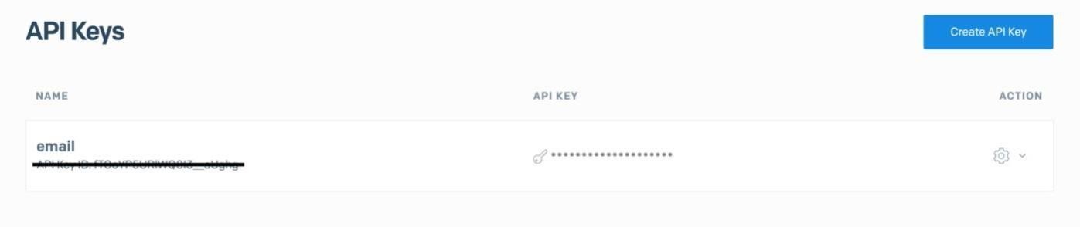

API keys list

1. Email verification

The next thing we have to do is to verify our email which we will be using to send emails. We can verify our email in two ways, either by single sender verification or domain verification.

**Coding:**

import os

from sendgrid import SendGridAPIClient from sendgrid.helpers.mail import Mail

message = Mail( from_email="[verified_email@gmail.com](mailto:verified_email@gmail.com)", to_emails="[receiver@gmail.com](mailto:receiver@gmail.com)", subject="test", html_content="<p>hi</hi>"

)

try:

sg = SendGridAPIClient("XXXX API key XXXXXX") response = sg.send(message)

except Exception as e: print(e)

The code example

Let us create a simple program in python to send an email. First, we

have to install the SendGrid Python library. You can easily install it using pip by running the following command in your terminal.

$ pip install sendgrid

Once the package is installed, we can send emails using SendGrid. I have added a python code example below.

Conclusion

Hope this article is helpful. In addition to python, they also support other programming languages right out of the box.

Sample code :

import os

from sendgrid import SendGridAPIClient from sendgrid.helpers.mail import Mail

message = Mail( from_email='from_email@example.com', to_emails='to@example.com', subject='Sending with Twilio SendGrid is Fun',

html_content='<strong>and easy to do anywhere, even with Python</strong>') try:

sg = SendGridAPIClient(os.environ.get('SENDGRID_API_KEY')) response = sg.send(message)

print(response.status_code) print(response.body) print(response.headers)

except Exception as e: print(e.message)